**TASK 01:**

#include <iostream>

using namespace std;

int main(){

int ans = 0, x = 0, y = 1 ,values;

cout<<"Enter number of values in the sequence: ";

cin>>values;

ans = x + y;

cout<<x<<", "<<y<<", "<<ans<<", ";

for (int i = 0; i<values-3; i++) {

x = y;

y = ans;

ans = x + y;

for (int j = 0; j<1; j++) {

cout<<ans<<" , ";

}}

return 0;

}

**OUTPUT:**

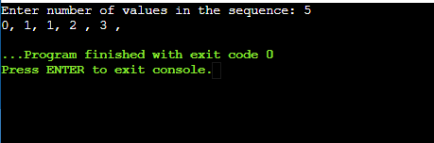

**TASK 02:**

#include <iostream>

using namespace std;

int main()

{

int rows, x = 0;

cout<<"Enter the number of rows: ";

cin>>rows;

for (int i = 1; i<=rows; i++) {

for (int j = 1; j<=i; j++) {

cout<<" "<< x++;

}

cout<<endl;

}

return 0;

}

**OUTPUT:**

